INSTRUCTIONS TO AUTHORS FOR THE PREPARATION OF EXTENDED ABSTRACTS FOR GLOBAL STONE CONGRESS 2025

A.A. Surname¹*, B.B. Surname², C.C. Surname³, D.D. Surname¹

- Affiliation of the 1st author, *e-mail@com.pt of the 1st author
- Affiliation of the 2nd author,
- Affiliation of the 3rd author

Summary: An English short summary with a maximum of 150 words in Calibri 10 pt and single spacing 0 pt. Justified text.

Key words: word 1, word 2, word 3, word 4, word 5

Only texts written in English are accepted. Documents must be in Windows or MacOS format, version.

Deadline for submission of extended abstract/paper 31 December 2024, the delay compromises the date of publication of the journal. The papers must be sent to globalstone2025@eagme.gr

Each paper should have a maximum of 4 pages, including figures, tables, references and acknowledgments.

The texts included in the figures must be large enough to be read in the figures that make up the body of the article. Pages should have 2.5 cm of top and bottom margins, and 2 cm of side margins in DIN A4 format.

The text must be written in Calibri, 10 pt, formatted in 2 columns of 8.5 cm each, with single spacing and 5 pt between paragraphs.

The magazine will be published online so all images, tables, diagrams and graphs can be submitted in colour. For the printed version, each paper will be entitled to two pages in colour and the authors must clearly indicate the pages to be printed in colour.

Papers will be sent anonymously to the scientific committee for review to an evaluation by a panel of experts. Works whose quality does not reach the minimum required may not be accepted.

Figures must be inserted in the text (Fig. 1), in the corresponding position, adapted to the column, or, adapted to the entire width of the page (Fig. 2). They must be adequately sized and have a minimum resolution of 250 dpi.

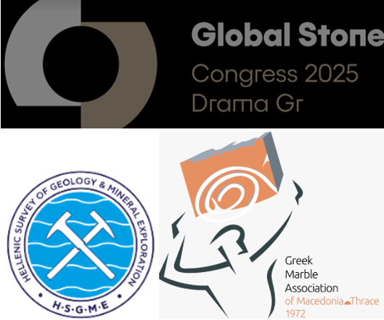

Fig. 1. Figure captions (can be maps, diagrams, photographs, etc.) must be written in italics, 8pt size, with consecutive numbering.

Tables must be numbered independently (Table 1; Table 2; Table 3; etc.). Table caption must precede the table and must be written in italics, 8pt size, font calibri. Table text must be written in font calibri, 9pt size.

Table 1. Example of table. Centered justification for alphanumeric text and right justification for numbers. Table citation in text: “Tab. 1”.
Material | Number of tests |  | Production in m³/year
A |  | 5 | 15,000
B |  | 10 | 200,000
C |  | 3 | 500
D |  | 120 | 1,260

All mathematical notations should be kept outside normal text paragraphs with the exception of single (or very simple combination of) symbols. They must be numbered by using a right-sided numbering between squared parentheses as in the following example:

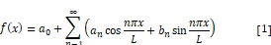

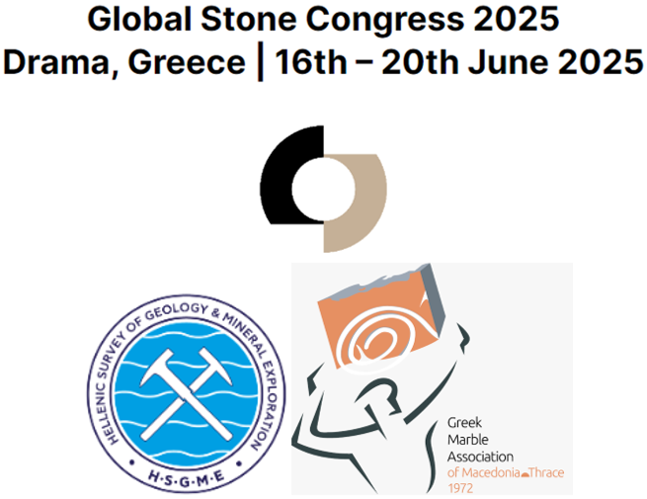

Fig. 2. Full-width figures should look like this.

Acknowledgments: In the Acknowledgments section, the authors may credit others for their guidance, helping or funding.

References section follows Acknowledgments. References must be mentioned in the text inside parentheses (Germano et. Al., 2014), in the corresponding position. References must be, firstly, in alphabetical order and then ordered by date, descending. In the following section, there are some examples of references formatting related to edited books, conference proceedings, journal papers, scientific reports and web sites.

References

American Psychological Association (2009). Publication Manual of the American Psychological Association (6th ed.). Washington, DC: Author.

BARD, L.P. Stone in Architecture (1980). Translated from the Dutch into English by George STREIG. London: Thames and Hudson. 520 p. ISBN 1-824654-90-1.

BRITISH STANDARDS INSTITUTE. BS ISO 690: Information and documentation — Guidelines for bibliographic references and citations to information resources. Reference number ISO 690:2010(E). Third edition. London: British Standards Institute, 2010.

Germano, D.; Lopes, L.; Gomes, C.; Santos, A.; Martins, R. (2014). O Impacte das Pedreiras Inactivas na fauna, Flora e Vegetação da Zona dos Mármores: Problema ou Benefício? Callípole, Revista de Cultura nº 21; Câmara Municipal de Vila Viçosa; pp. 149 – 171.

Guo, H., Todhunter, C., Qu, Q. and Qin, Z., (2015). Longwall horizontal gas drainage through goaf pressure control. International Journal of Coal Geology. 150-151, 276-286.

Juvandes, L.F.P. (2002). Materiais Compósitos Reforçados com Fibras, FRP. Ciência dos Materiais, Licenciatura em Engenharia Civil, Faculdade de Engenharia da Universidade do Porto, Departamento de Engenharia Civil, pp. 76.

McLEAN, Renwick. Canary Islands species threatened by soft borders. International Herald Tribune [online]. Paris, France, 21 June 2006 [viewed 7 July 2006]. Available from: http://www.iht.com/articles/2006/06/20/news/ecology.php

